Geomec 3.2 Specifications
Prescribed displacements from global strain tensor

- Input of global strain tensor

General Option: 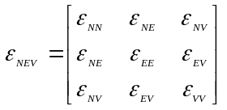
Note: while the user enters engineering strains, scientific strains
are used internally.

Vertical Option: 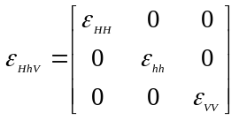, azimuth = ξ
The global strain tensor in NEV system can then be deduced:
Rotation matrix, 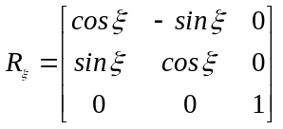
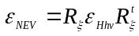

Note: a standard function should already be available to rotate a
tensor by a given angle (ξ) around a specified vector (V).

- Definition of reference point, reference line and reference surface

To avoid rigid body motion when deducing a displacement field from a strain tensor various fixities need to be defined:
  - one reference point, with its position unchanged by the deformation
  - one reference line, with its direction unchanged by the deformation
  - one reference plane, with its orientation unchanged by the deformation.

The reference objects are chose as follow (=convention):
  - reference point = boundary corner point with greatest depth
(secondary criteria= smallest northing and easting)
  - reference line = horizontal line defined by specified azimuth, β
  - reference plane = Horizontal plane
- Rotation to reference system

From these fixities, a reference system of axis, xyz, is set up:
V
N
E
Reference point
Reference line
β
x
y
z

x is in the direction of the reference line
z is the vertical direction, pointing downwards
y is normal to x and y
xyz is a right-hand side system
The rotation matrix from NEV to xyz is 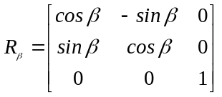
The global strain tensor expressed in xyz is obtained 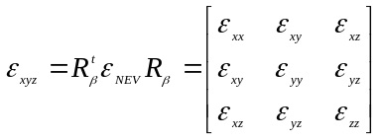

- Calculation of displacement field

The displacements in the x, y and z directions are noted u, v and w respectively.
The fixities adopted in 2- result in: 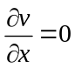 , 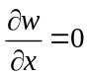 and 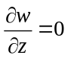
Consequently, the linear displacement field is obtained in function of the position vector:
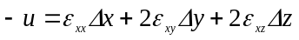
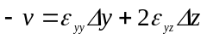
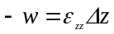

In matrix notation, using P for the position vector of the considered point and U for the deduced displacement vector in this point:
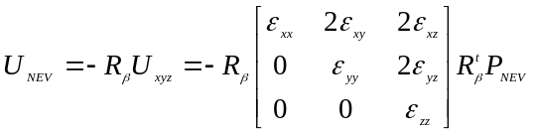
where P_{NEV} is the vector starting at the reference point and ending at the
considered point, expressed in the NEV system

